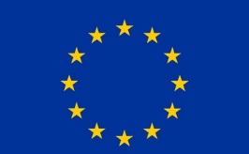

MEDIA EQUIPMENT FORM
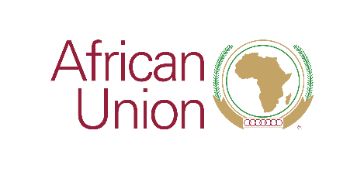 |  | 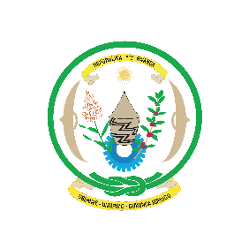

SECOND AU-EU MINISTERIAL MEETING
25th -26th October 2021
Kigali, Rwanda

List of equipment for Mr. / Mrs. / Ms. / other (please specify)

Full Name:__________________________________________________

Name of media represent: ___________________________________

NO | TYPE OF EQUIPMENT | SERIAL NUMBER | ESTIMATED VALUE (USD)

