 | MEDIA EQUIPMENT FORM
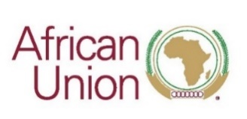 |  | 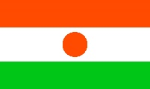

AFRICAN UNION SUMMIT ON INDUSTRIALIZATION AND ECONOMIC DIVERSIFICATION.
“Industrialising Africa: Renewed commitment towards an Inclusive and Sustainable Industrialization and Economic Diversification.”

20 – 25 November 2022. Niamey, Niger.
#AfricaIndustrialization

List of equipment for Mr. / Mrs. / Ms. / other (please specify)

__________________________________________________

Name of Media: ___________________________________

NO | TYPE OF EQUIPMENT | SERIAL NUMBER | VALUE (USD)

